Fitness Buddy on IBM Cloud

**Step1: To open IBM Cloud login page using the link cloud.ibm.com, enter the Gmail id and click on Continue.  
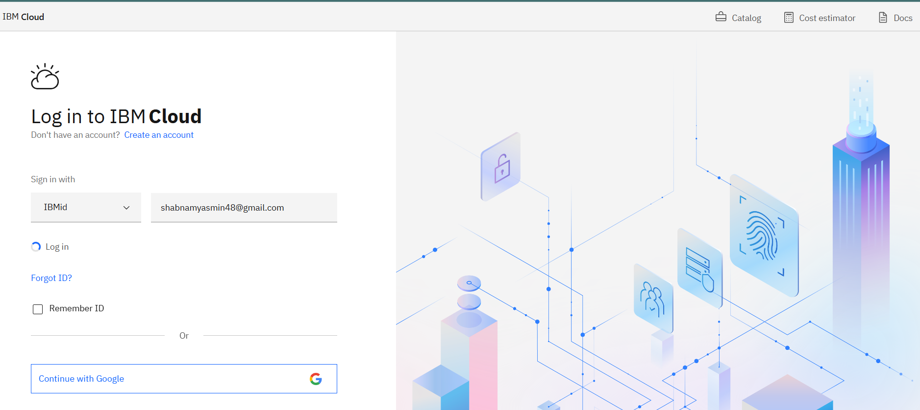  
  
  
  
  
Step2: Enter your password click on login.  
  
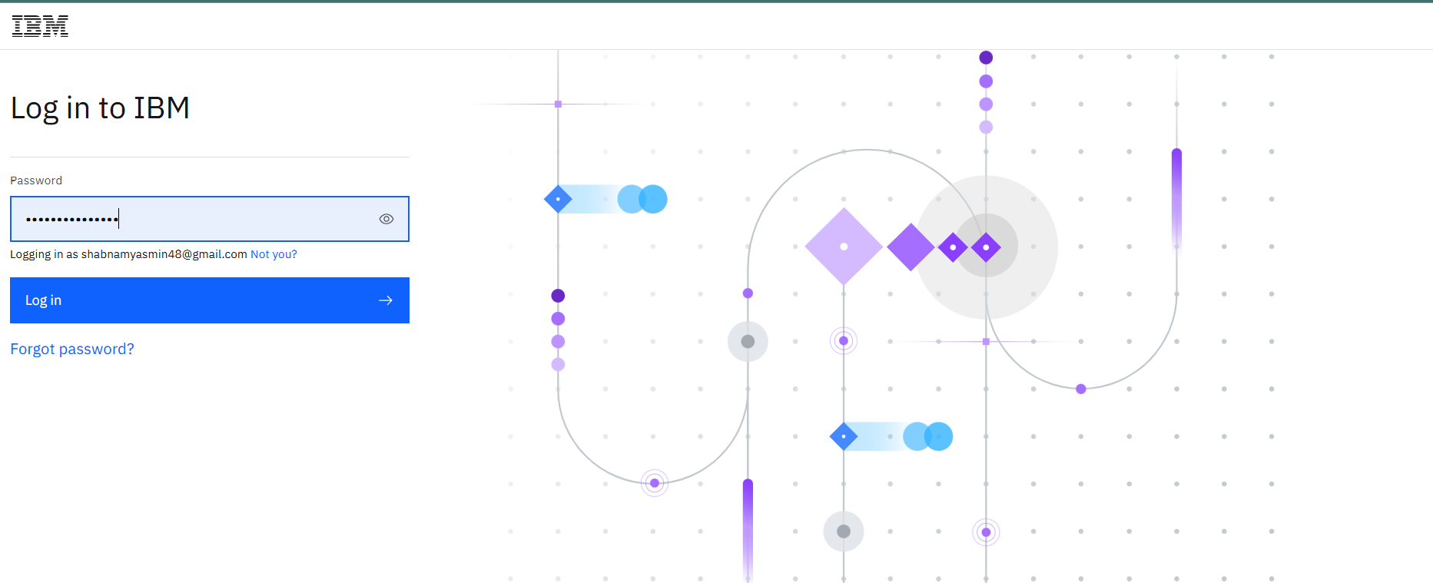**

**Step3: IBM Cloud Dashboard**

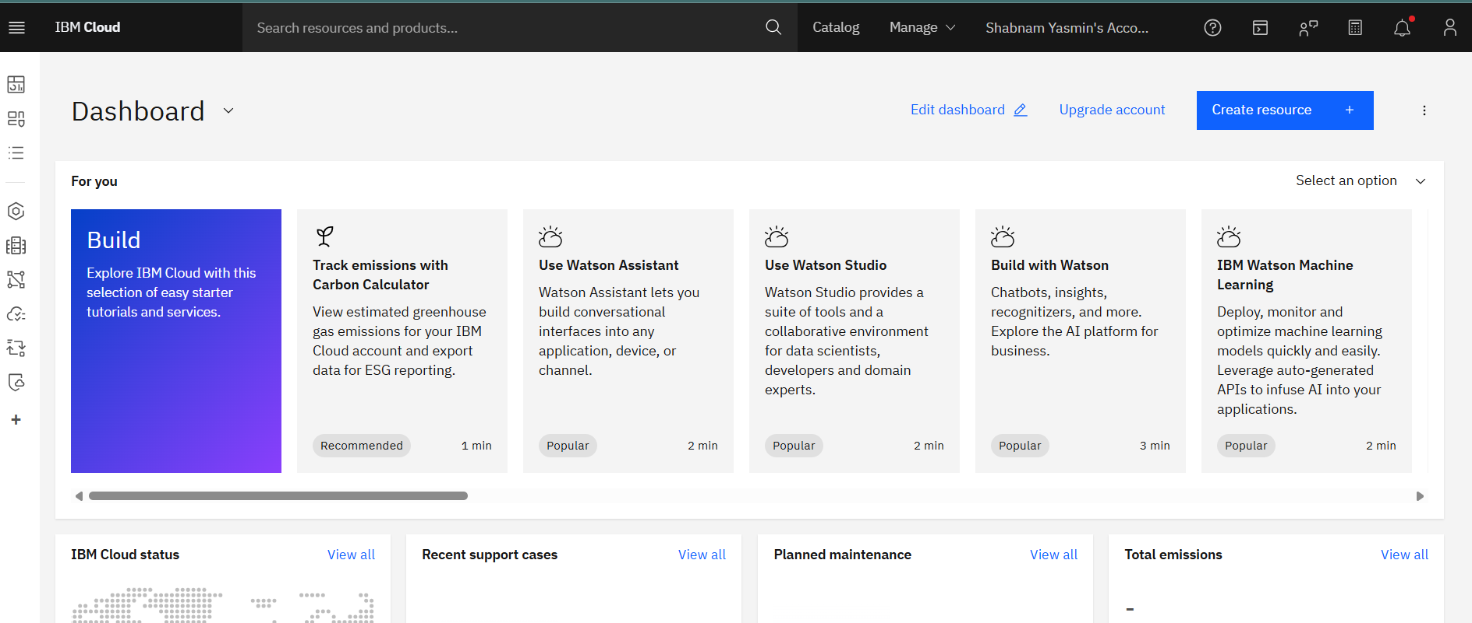

**Step-4: To search “Watsonx.ai Studio” on the search bar**

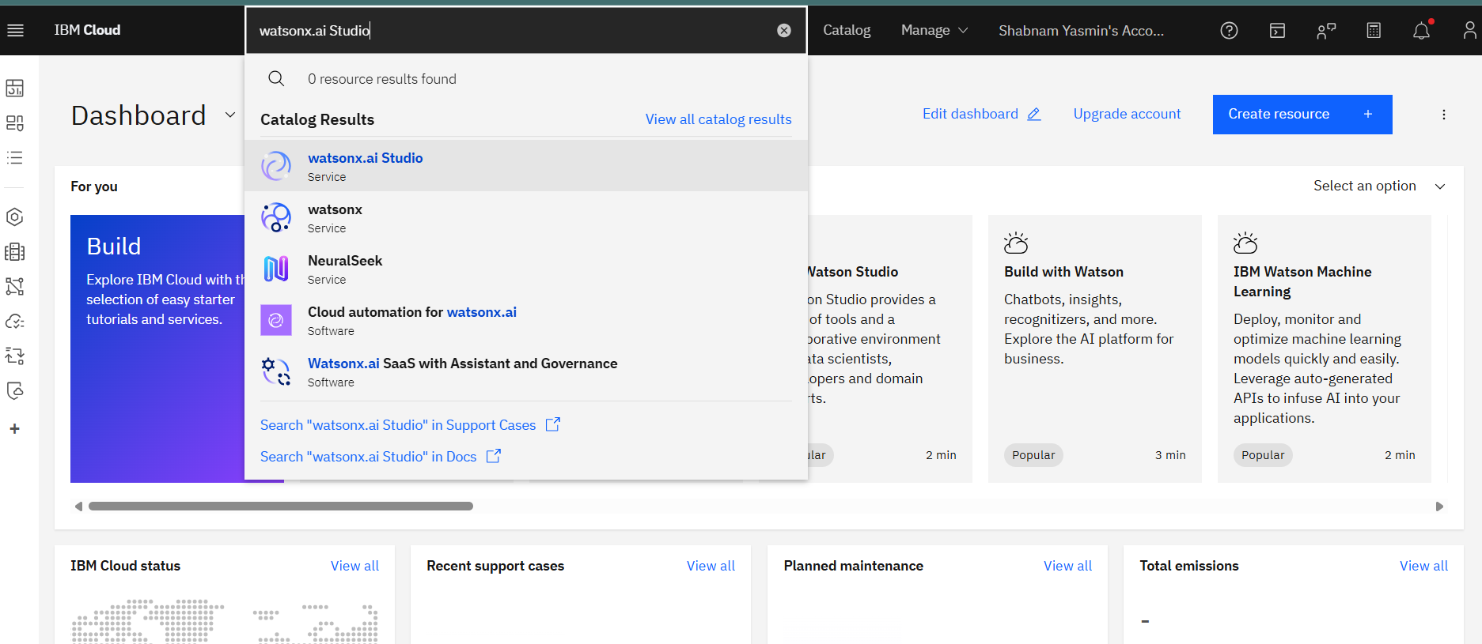

**Step-5: To login to IBM watsonx**

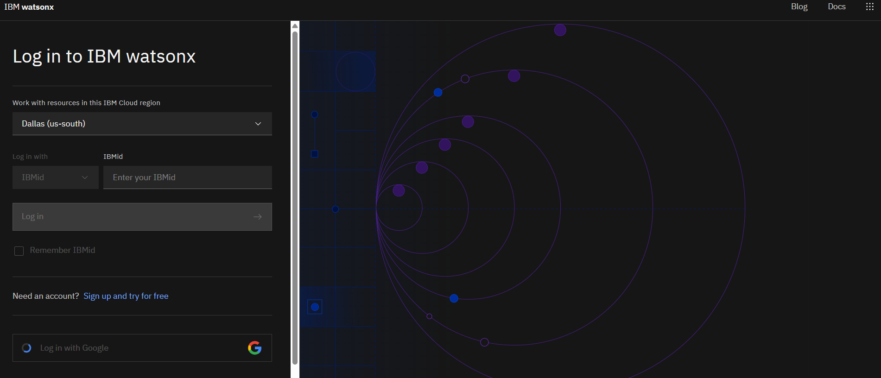

**Step-6: IBM watsonx**

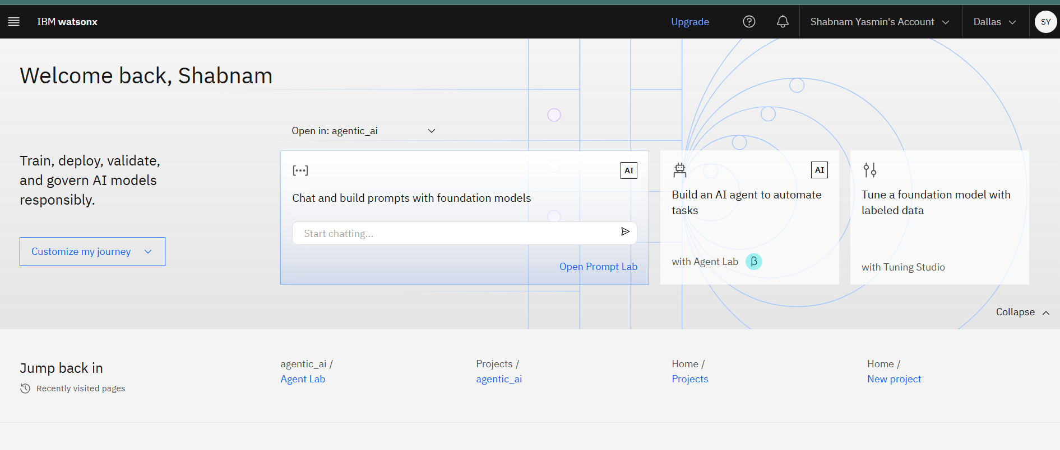

**Step-7: Created a project named ‘FitnessBuddy’**

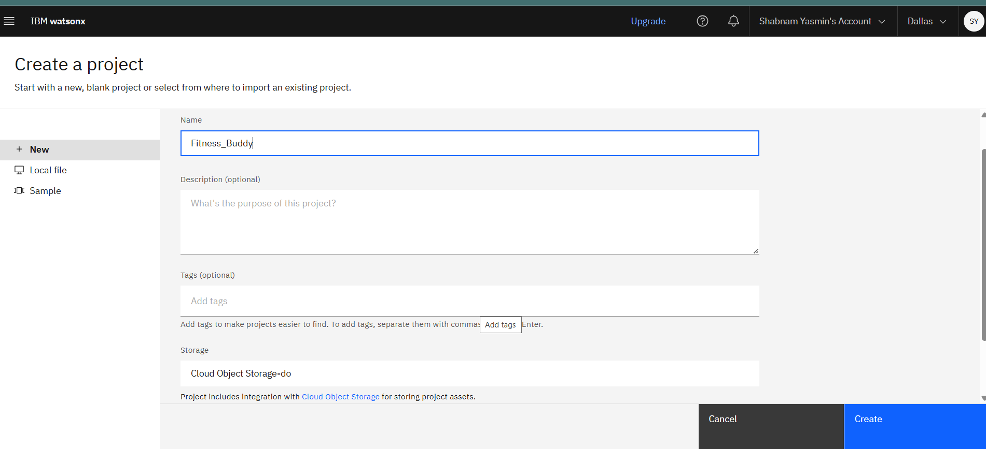

**Step-8:**

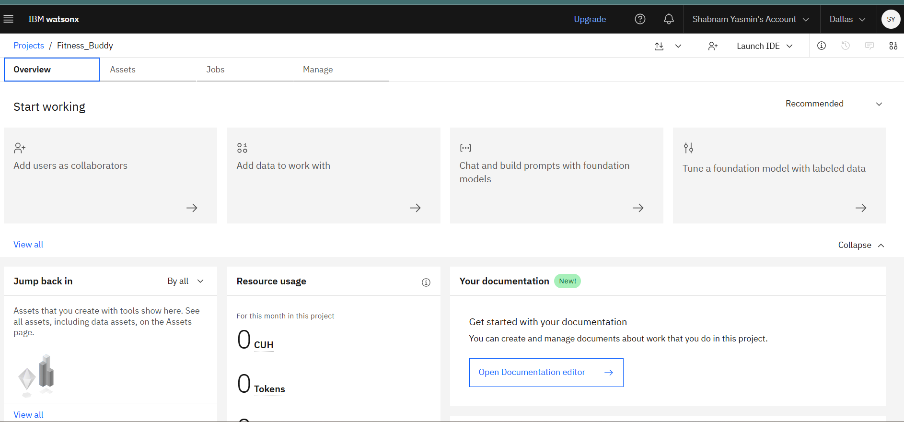

**Step-9: Integrating watsinx.ai Runtime  
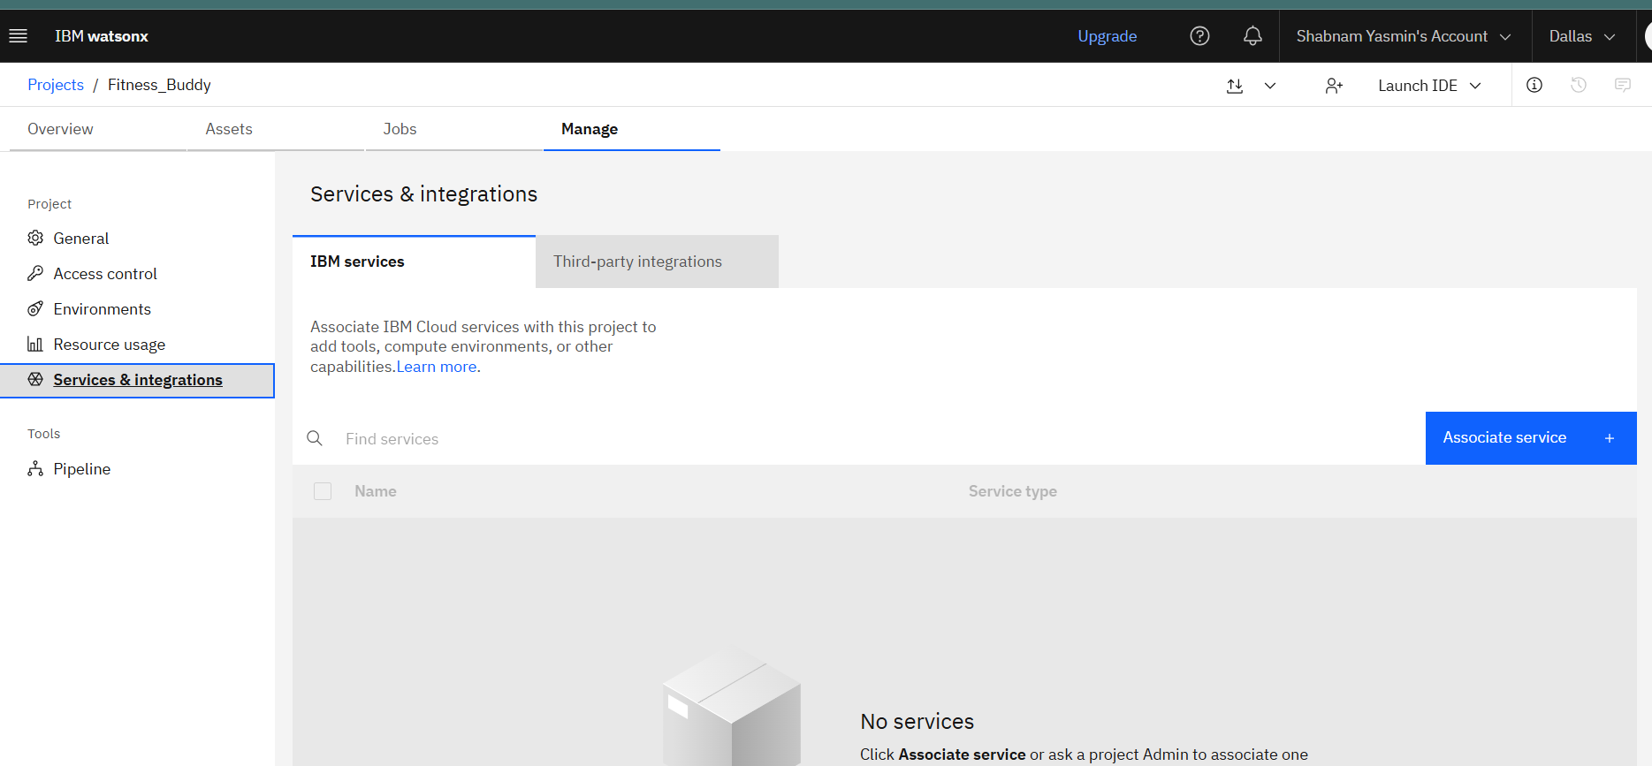**

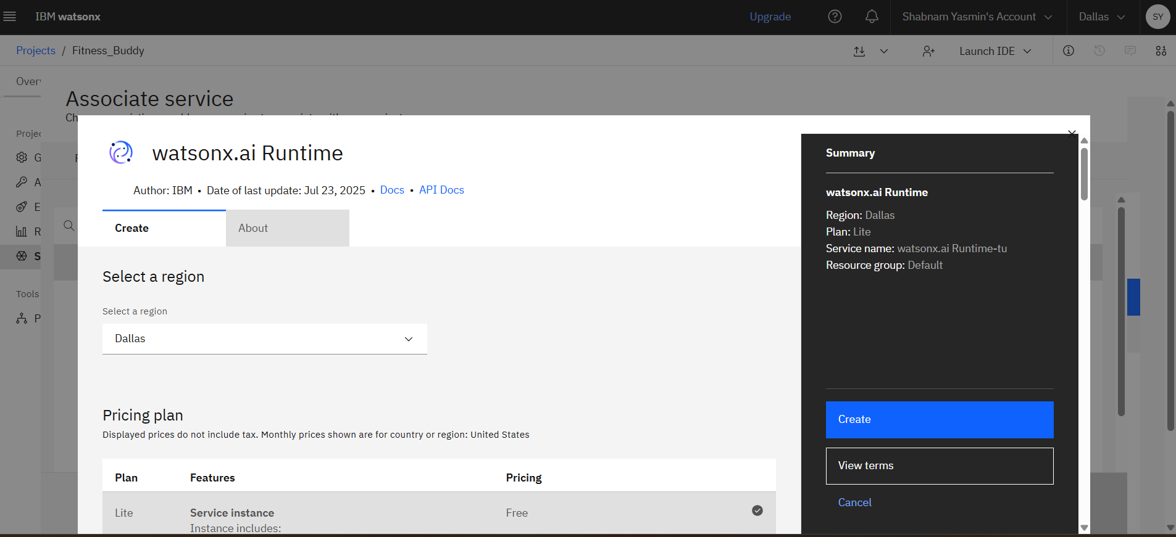

**Step-10: Associating service**

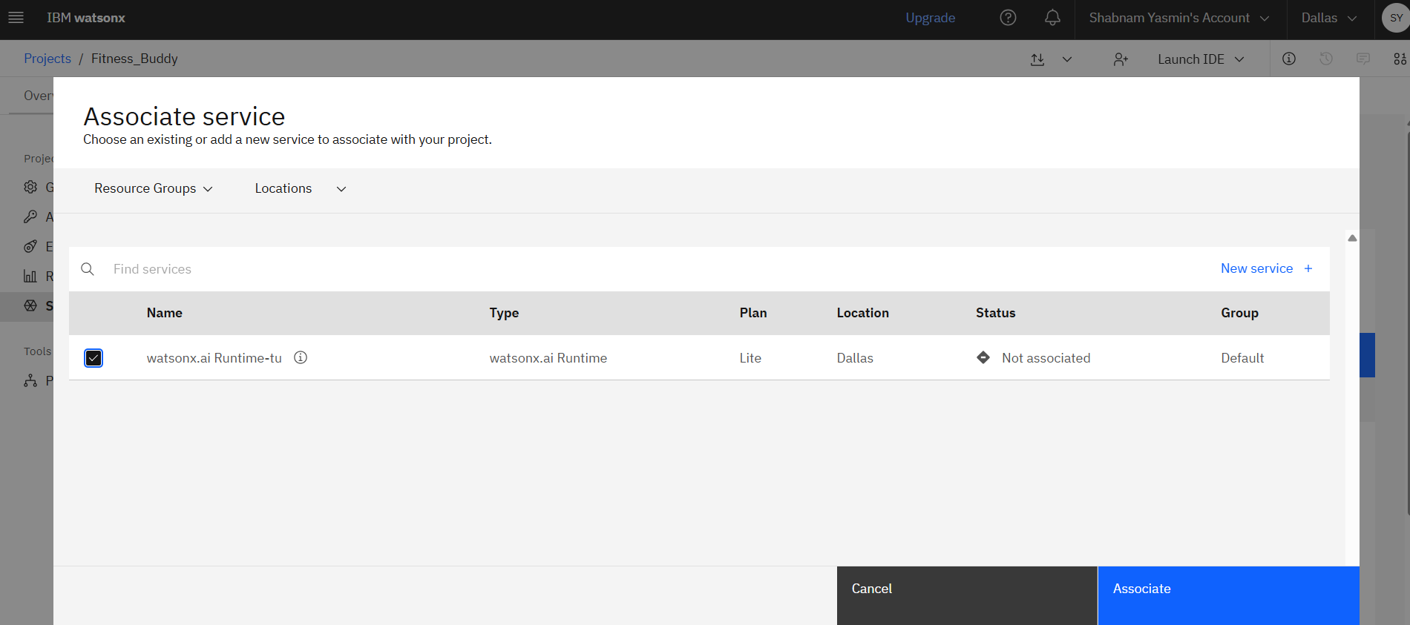

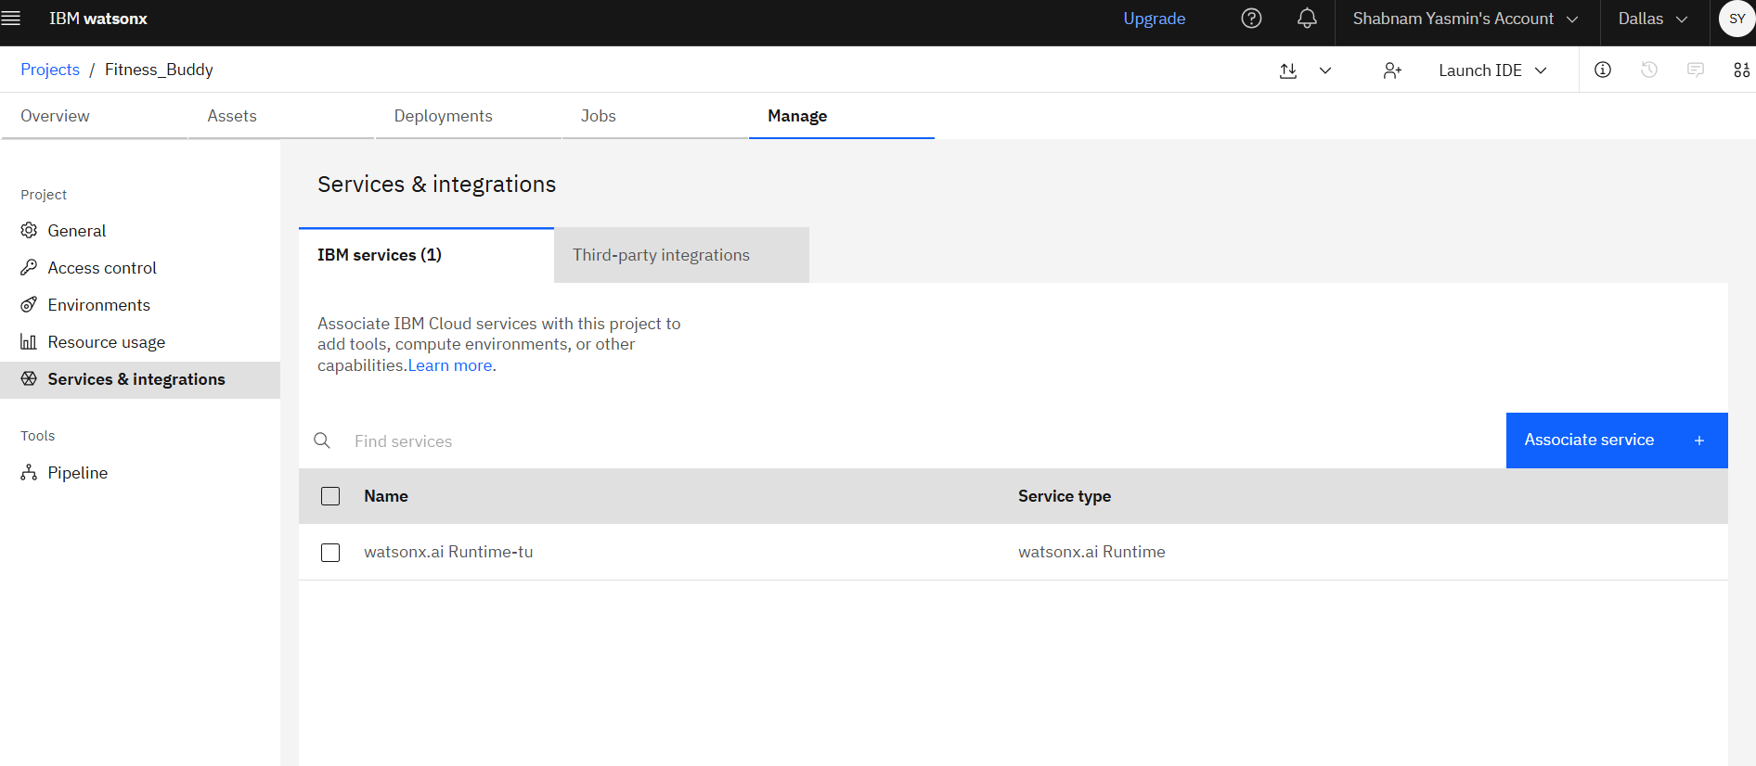

**Step-11: Going to Prompt Lab**

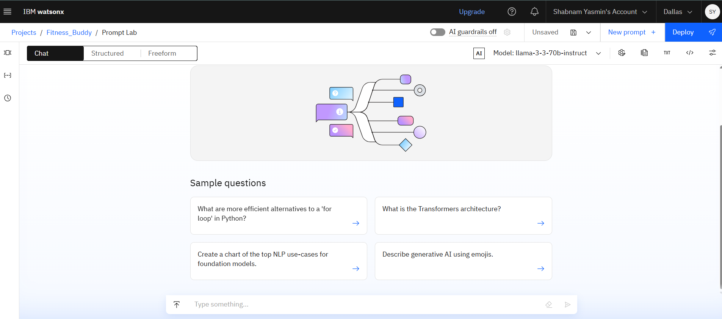

**Step-12: Changing model to mistral-large**

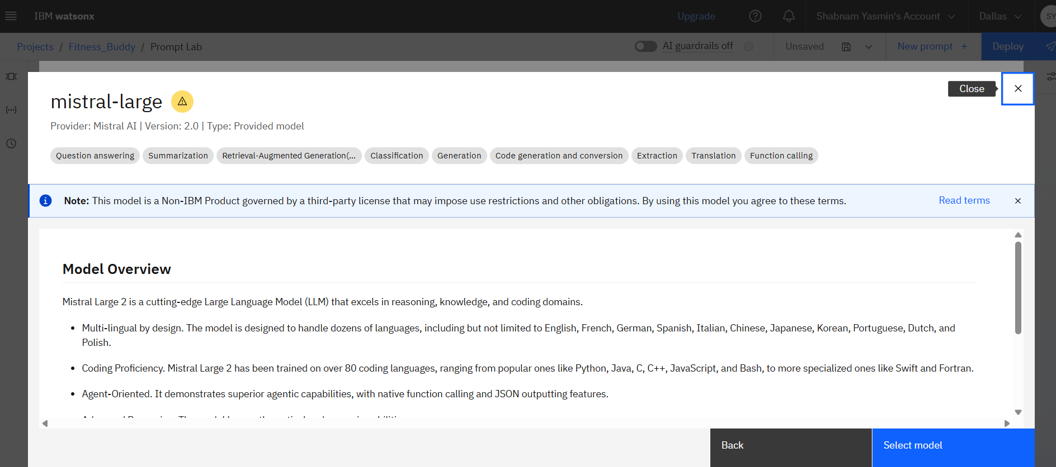

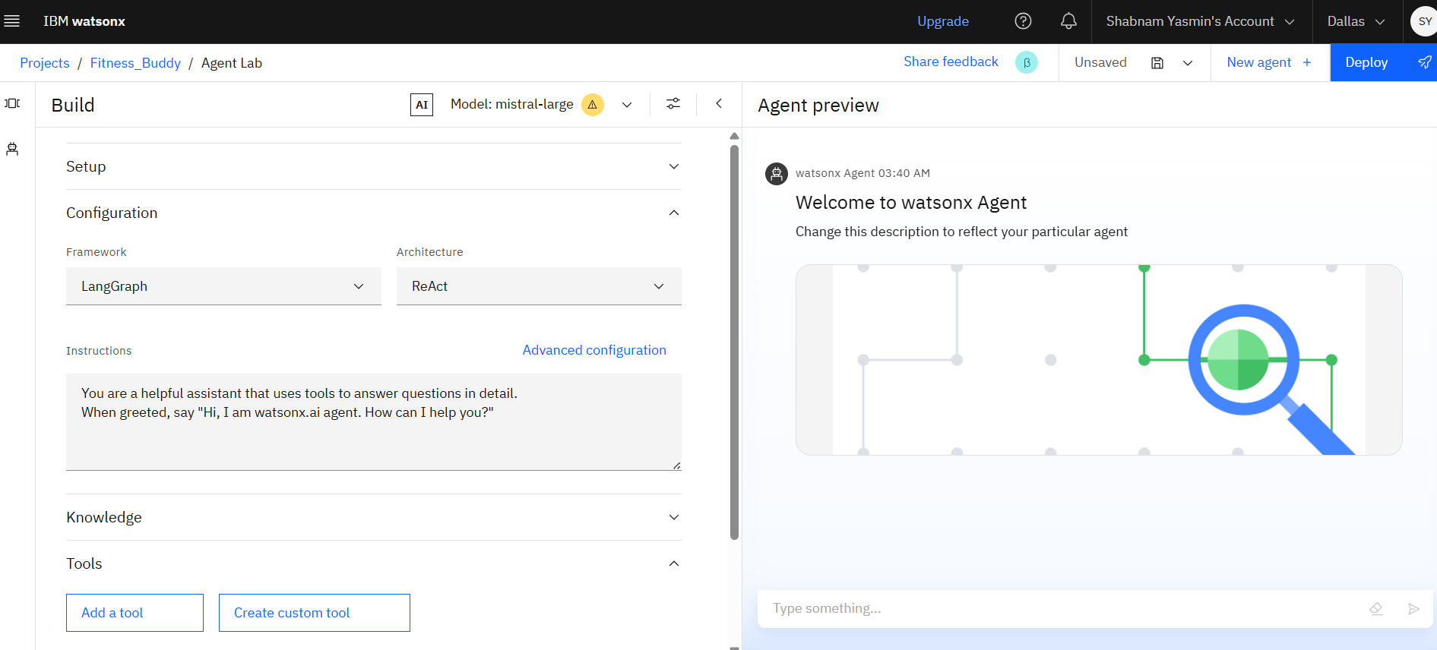

**Step-13: Selecting vector index in Knowledge**

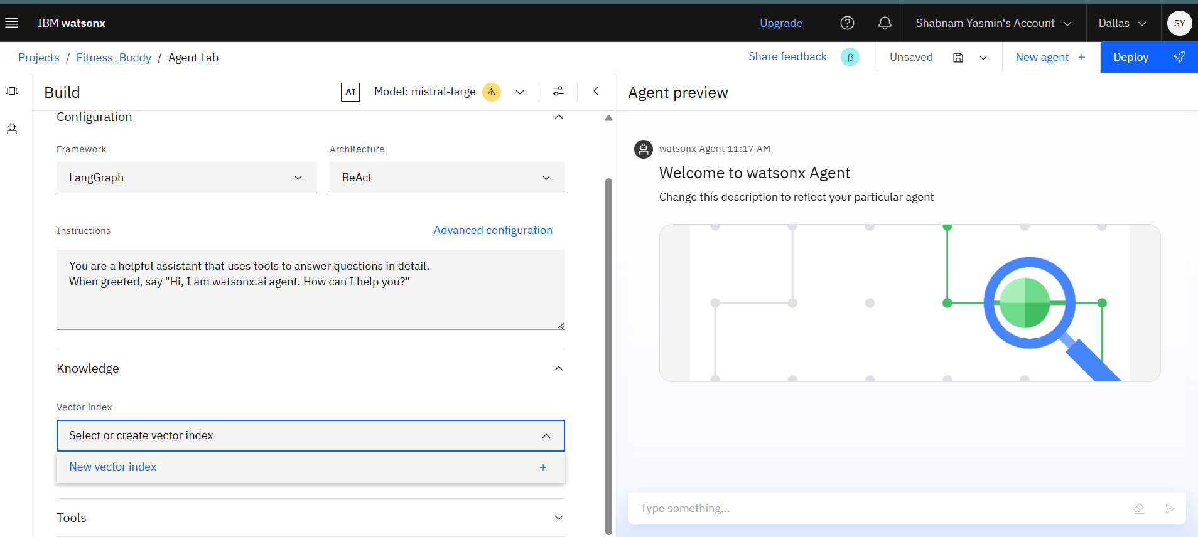

**Step-14: Adding file and clicking on Create**

**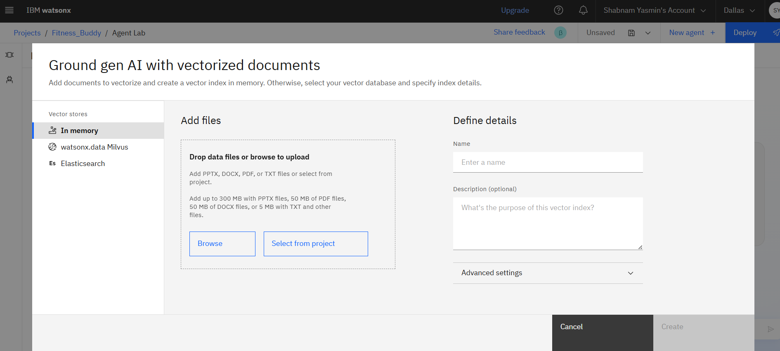  
  
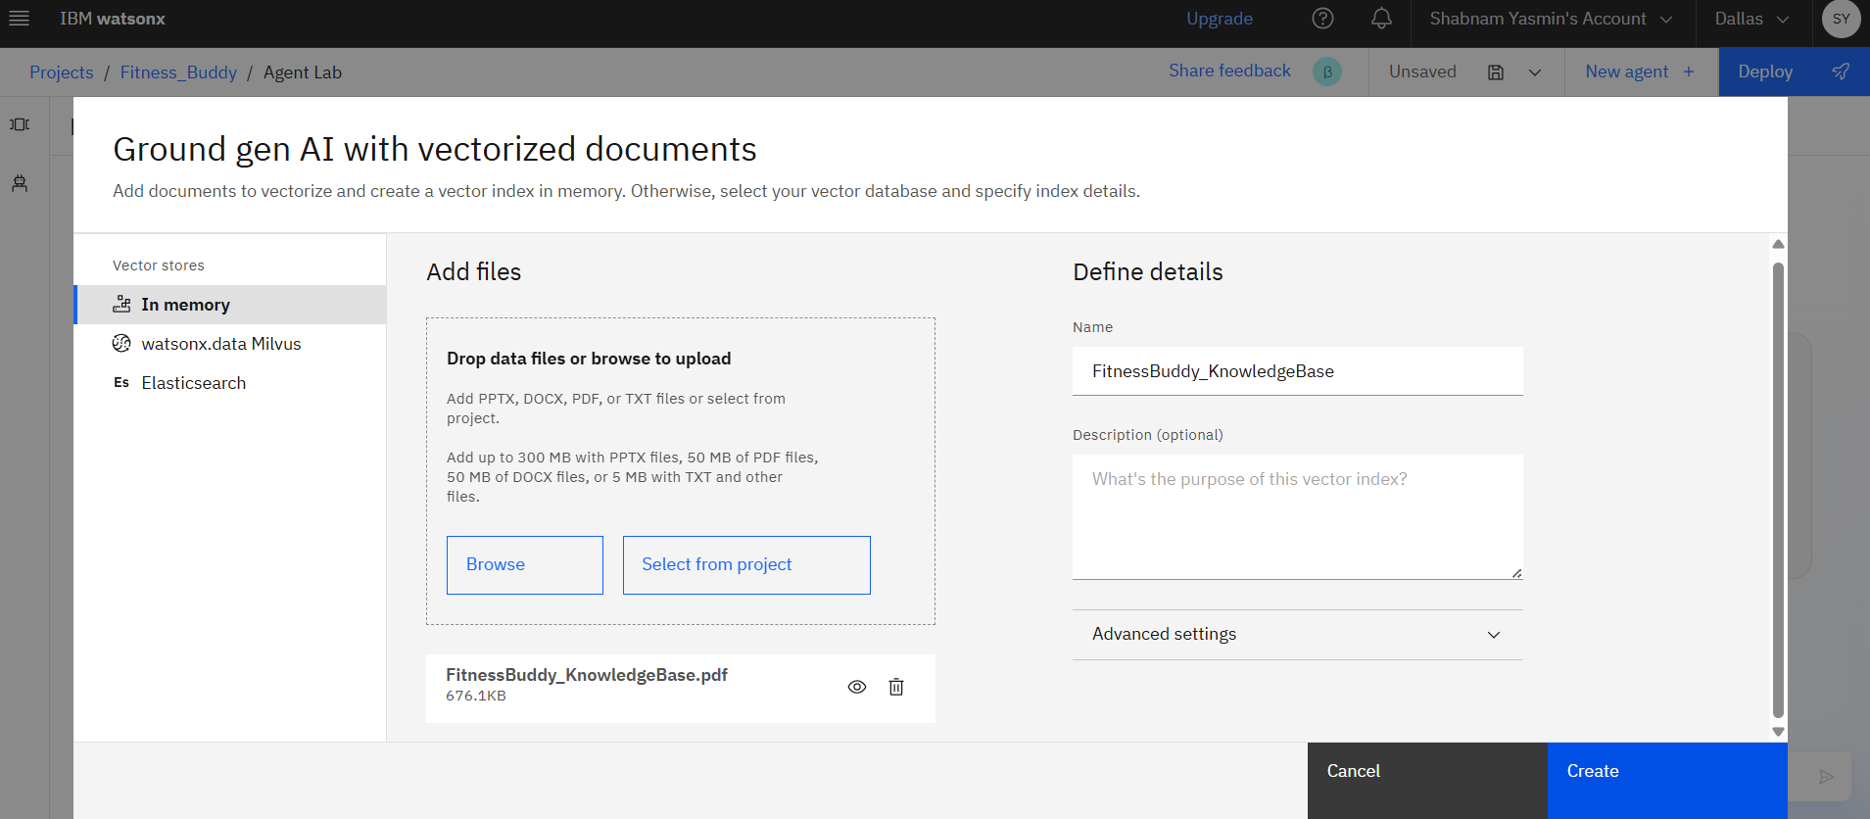**

**Step-15: Selecting the tools**

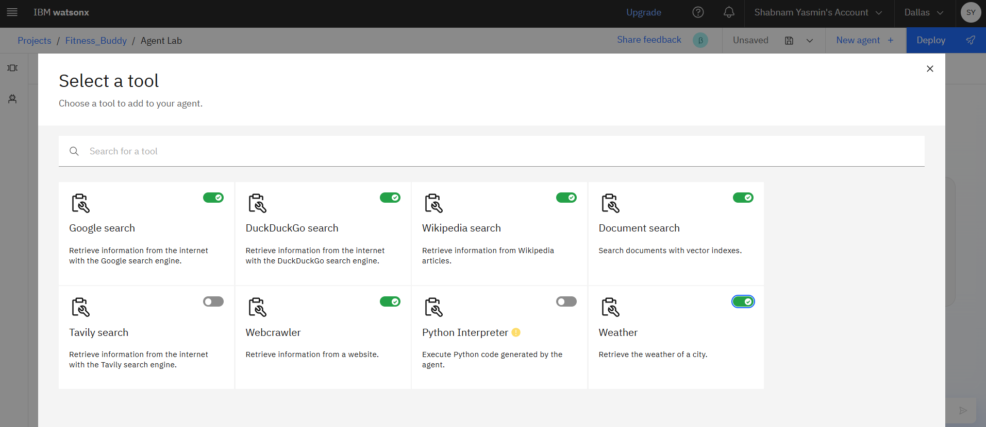

**Step-16: Agent Preview**

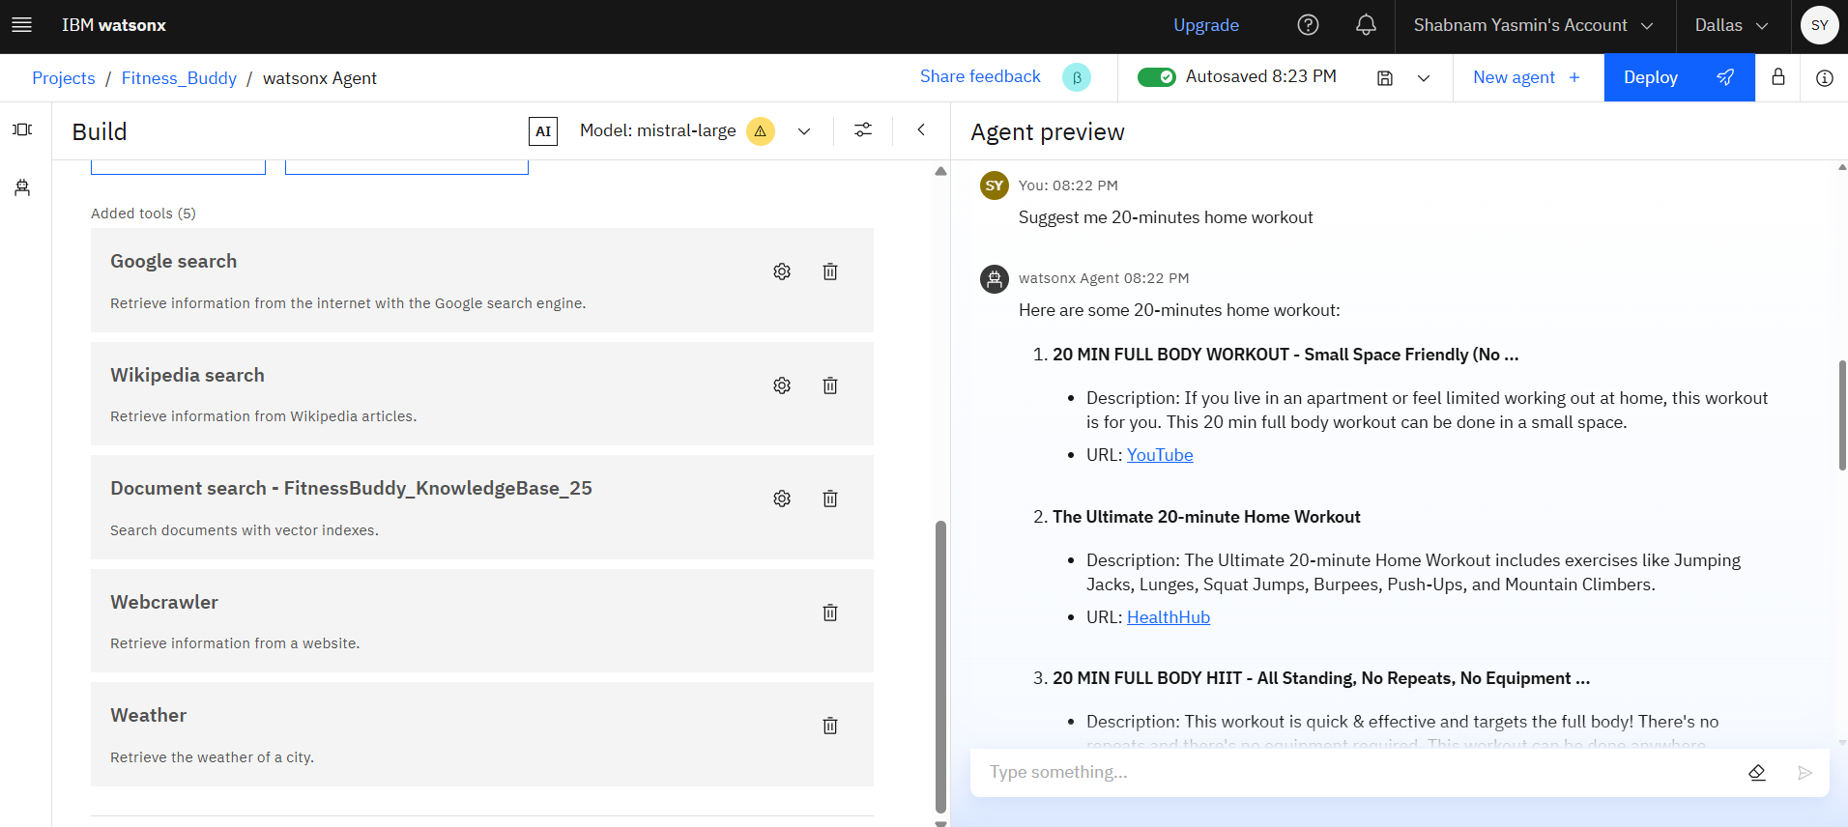

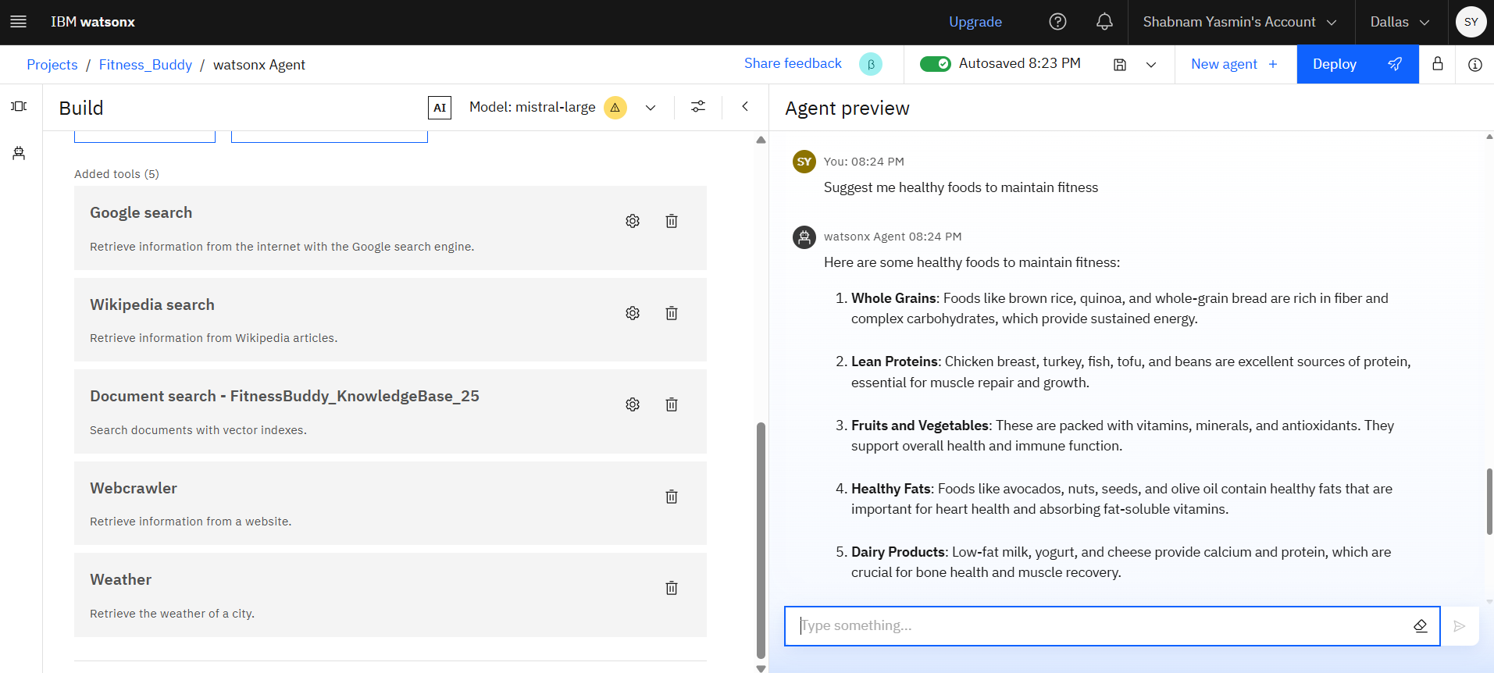

**Step-17: Saving as Standard Notebook and below is the Jupyter file**

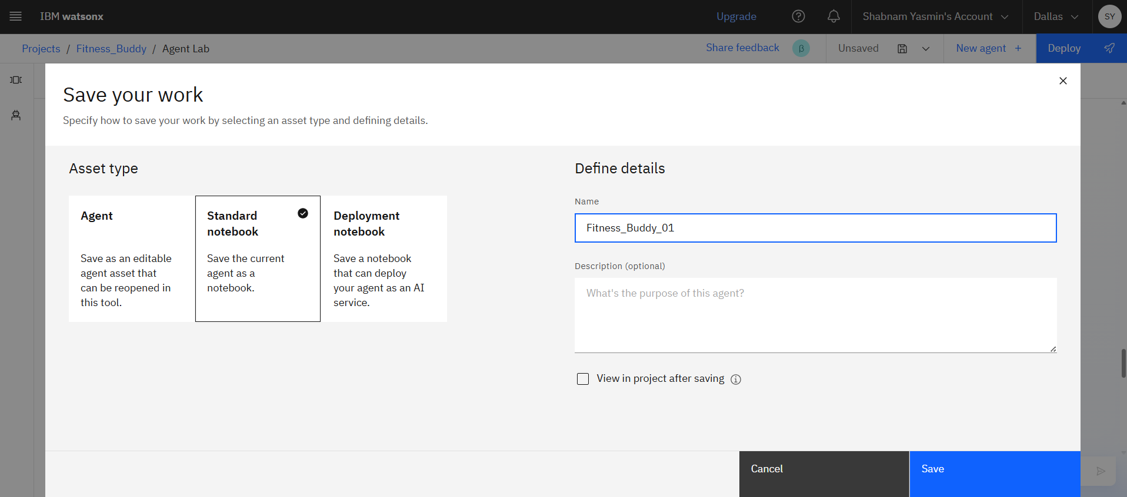

**Jupyter file:** 

**Step-18: Creating Deployment Space**

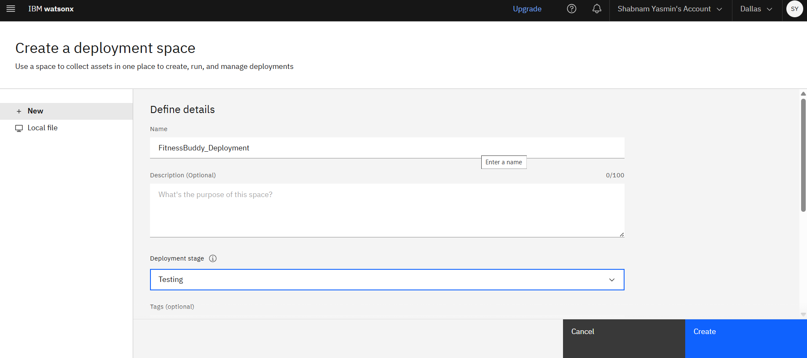

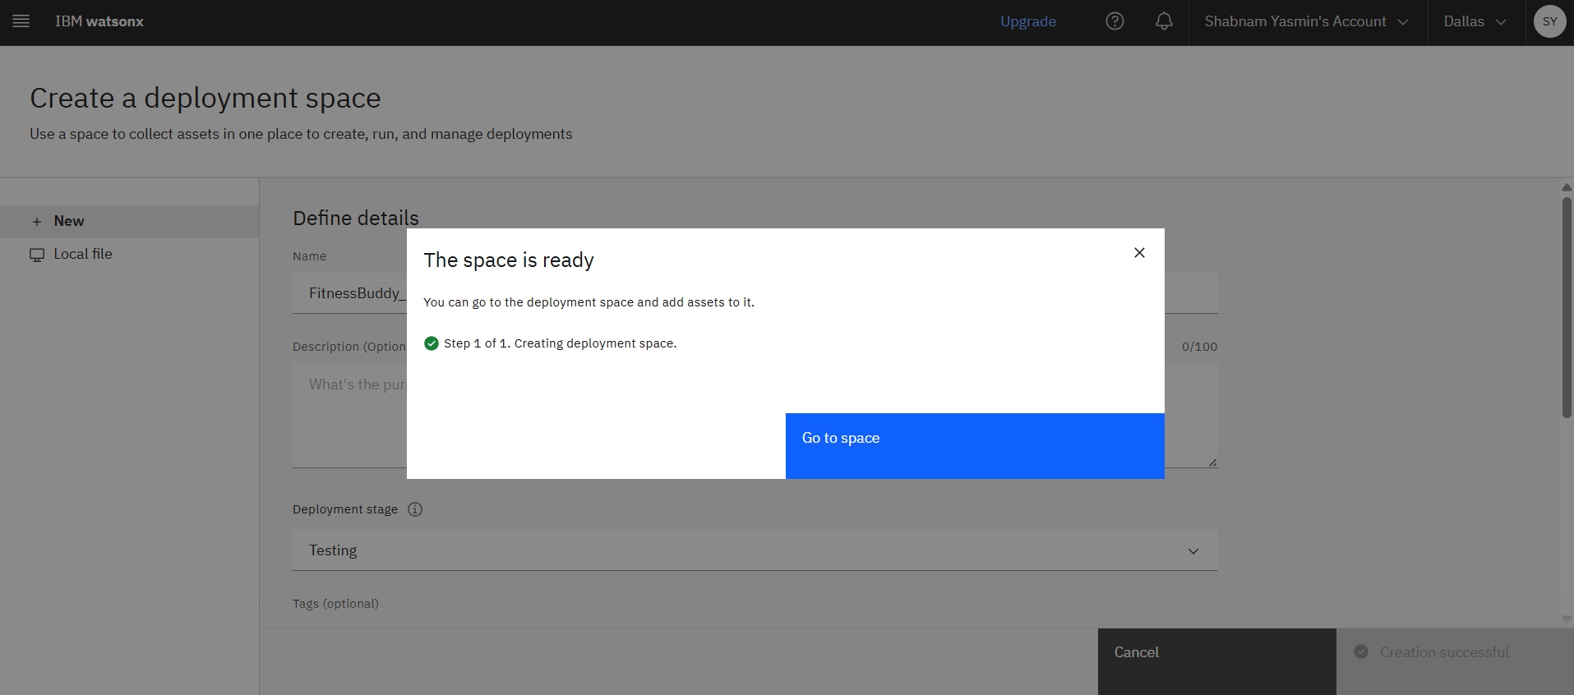

**Step-19: Deployment done**

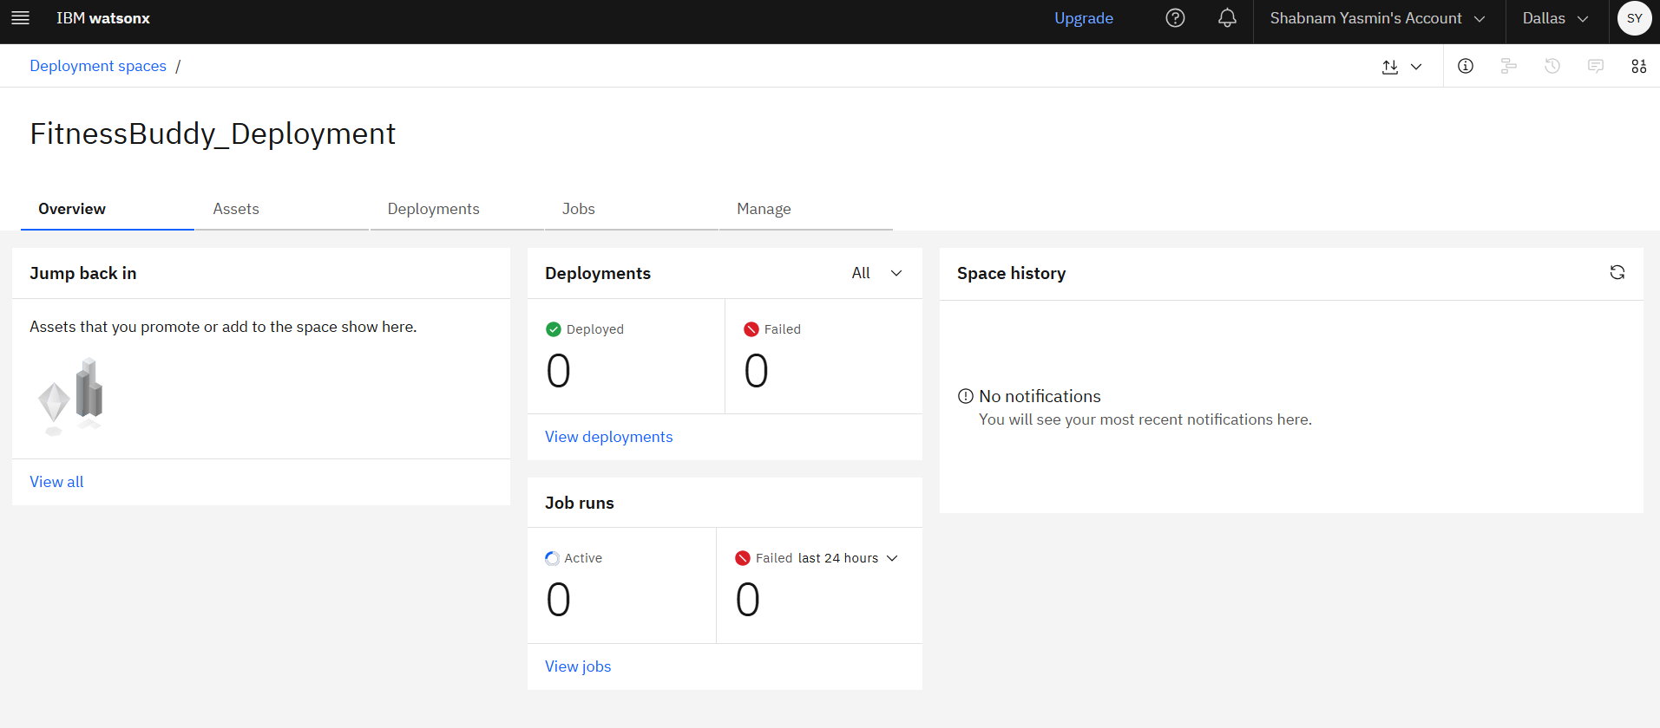

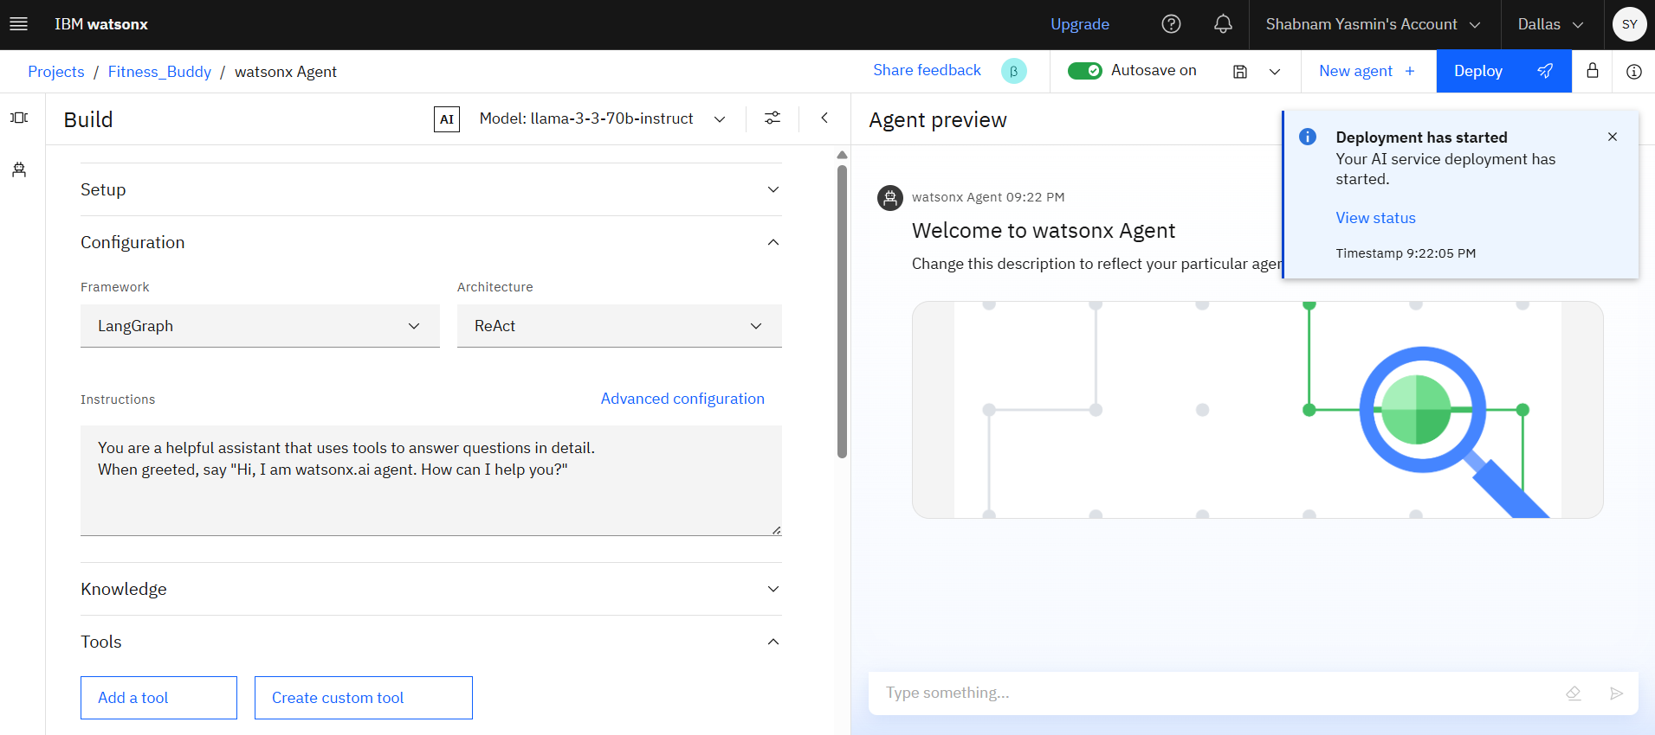

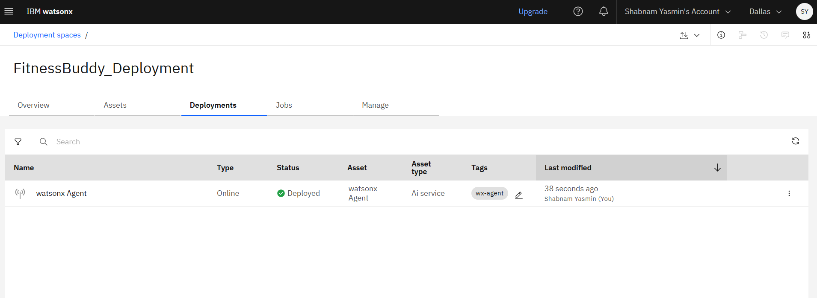

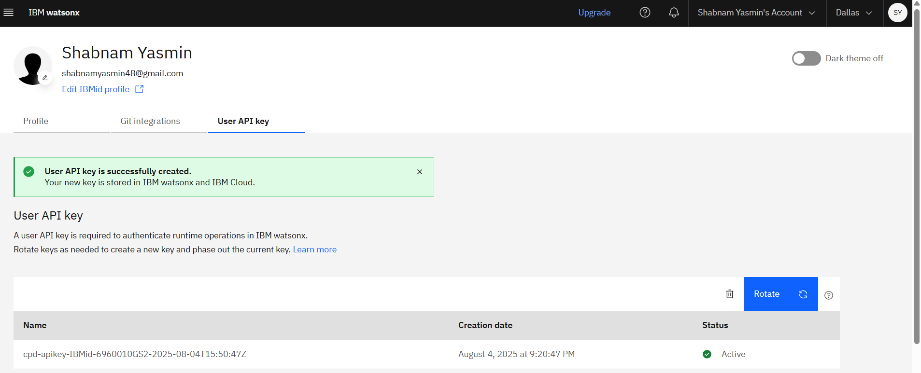

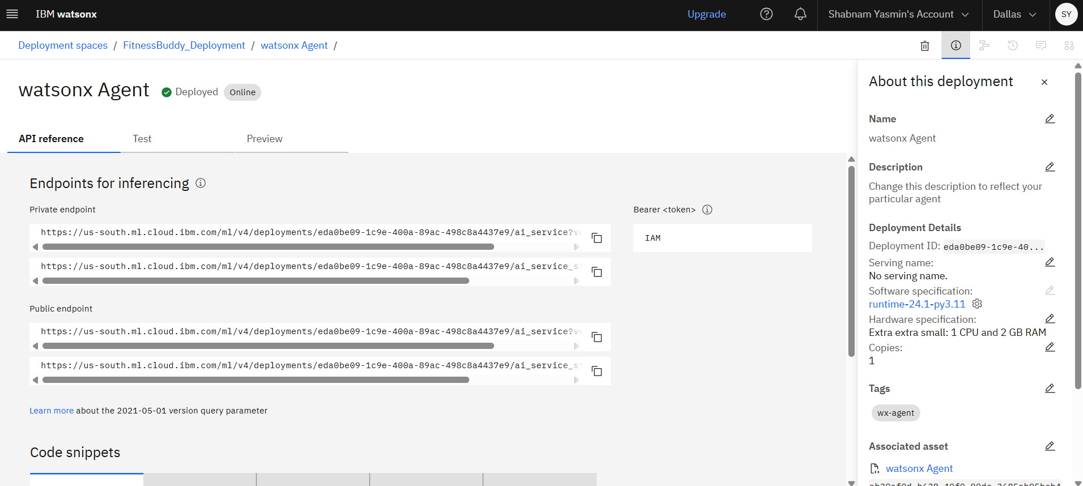

**Step-20: Deployed AI Agent Preview**



